CSV FILE UPLOAD
Step 1: Configure Snowflake Into command prompt :
snowsql <account_name> <user_name>
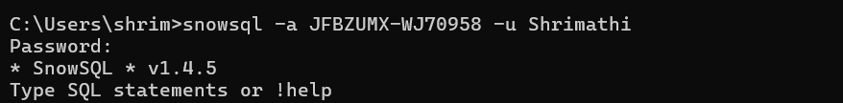
Step 2 :Create database ,Schema and Stage
Create or replace database <database_name>
Create or replace stage <stage_name>
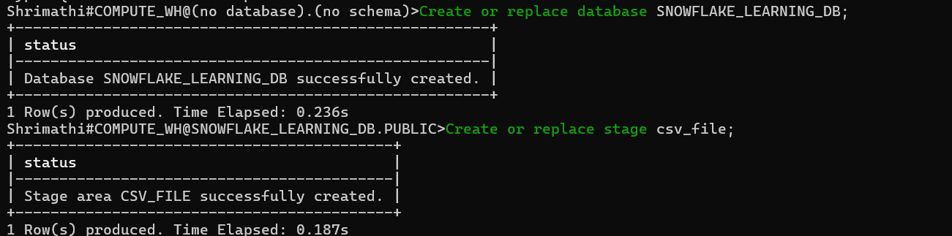
Step 3 :Create Table
Create or replace table table_name(id int,
name string,
salary number
);
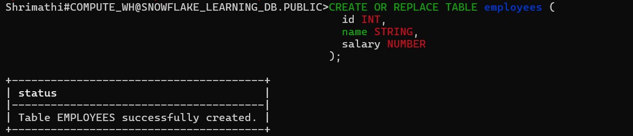
Step 4: Upload the file to stage
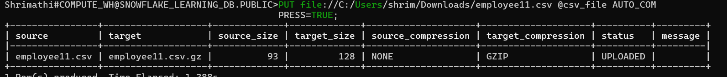
Step 5: Copy into the table
copy into employees from @csv_file/employee11.csv
file _format = (TYPE = CSV SKIP_HEADER = 1 FIELD_DELIMITER = ‘,’);
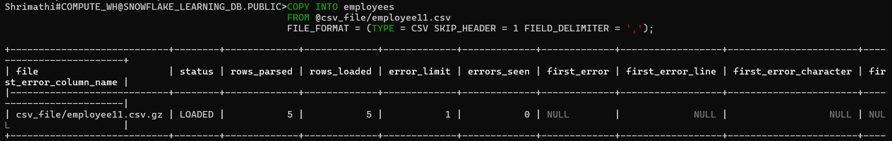
Step 6: Select Command
select * from employees
